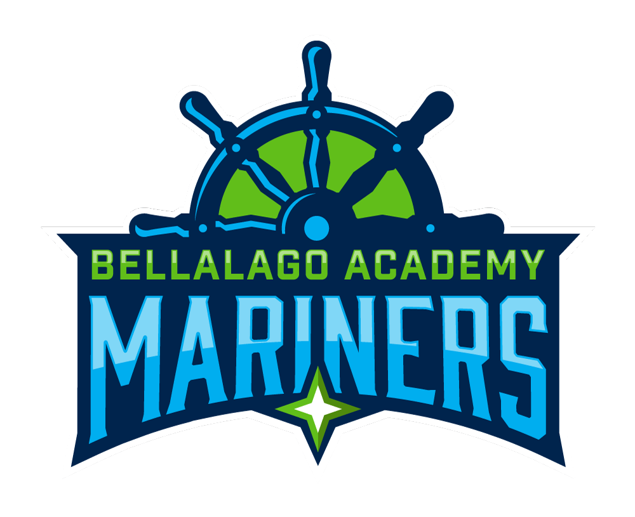
Be

Bellalago Academy
3651 Pleasant Hill Road
Kissimmee, FL 34746 Tel: 407.933.1690
www.bela.osceolaschools.net
Office Hours
8:30 AM – 5:00 PM
School Hours
9:20 AM- 4:20 PM (3:20 PM Wed.)
Students may enter campus at 8:50 AM
Breakfast served at 8:50 AM- 9:20 AM

Dr. Melanie Cleveland, Principal
Janine Bracco, Assistant Principal
Dania Perlaza, Assistant Principal

